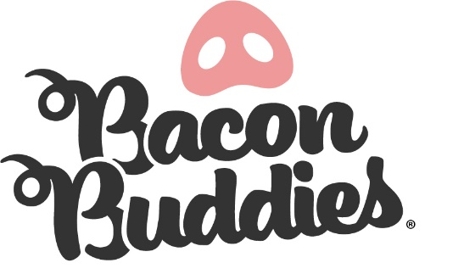
Worth County Bacon Buddies® Youth Mentor

Join us for the Bacon Buddies® Show at the Worth County Fair!
WHO: 4-H and FFA Members will be partnered with a person with an intellectual and/or developmental disability to teach them about exhibiting a pig.
WHAT: Bacon Buddies® participants will have the opportunity to experience showing a pig. The judge will assess how the mentors, participant and pig work together as a cohesive unit. All youth mentors will receive
a T-shirt (day of the event, prior to the show), along with other items.

WHEN: Friday June 20, 2025 immediately following the Swine Show
Arrival: 11:00 am
Timeline: 11:00 am, or immediately following the Swine Show,
Mentors, Pig and Participant Meet and Greet
1:45 p.m. Group Picture (All Participants and Mentors)
2-3 p.m. Bacon Buddies® Swine Show

WHERE: Worth County Fair Livestock Show Arena
REGISTRATION DEADLINE: Thursday June 19, 2025
EXPECTATIONS:
- 4-H/FFA youth mentor must be age 12 or older
- Enrolled in 4-H or FFA livestock project, (Preferably swine, but can pair you with someone in a swine project.)
- Arrive on time and dress in appropriate show attire, including Bacon Buddies® T-shirt
- Exhibitor will exhibit pig during the event and youth mentor will help assist and help when necessary
- Bacon Exhibitor and Mentor pairings will be assigned by Bacon Buddies® committee
- Stay for the entire Bacon Buddies® event and show
QUESTIONS: Please email: Mark Heggestad at mhtruck@live.com or 507-402-8743 or Dennis Johnson, at djohn@iastate.edu or 641-324-1531

Please see next pages for required registration form for youth mentors of this year’s Bacon Buddies® event.

Worth County Fair Bacon Buddies® Youth Mentor Registration Form
Youth Mentor Name: ________________________________________________________________________________
Address: ___________________________________________________________________________________________
City/State/Zip:______________________________________________________________________________________
Email Address: ______________________________________Cell Phone: ______________________________________
County _______________________ Age _________ Grade _________ School __________________________________
Possible suggestions for your Bacon Exhibitor match: _________________________________________________________
Gender (circle): Female Male
T-shirt (circle): Child Size: S M L XL Adult Size: S M L XL XXL

Parent/Legal Guardian Name(s): _______________________________________________________________________
Emergency Contact Name and Cell Number: ______________________________________________________________

Livestock experience:
Do you have experience with exhibiting swine? (circle): Yes No
Do you have a swine project to volunteer for this event? (circle): Yes No

Volunteer Agreement:
Please read carefully, then initial next to each.

_____ I will assist and support my participant to make their swine showing experience the best it can be.
_____ I will be respectful, kind, and courteous to all participants, exhibitors and volunteers.
_____ I will be a friend to my participant (Exhibitor) and I will strive to help build confidence and self-esteem in my participant.
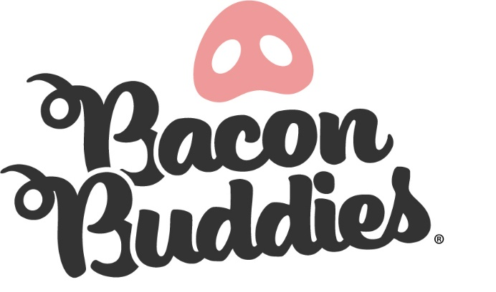
_____ I will at the swine show ring by 11:00 am and stay until the conclusion of the Bacon Buddies® event.
_____ I will wear appropriate show ring attire including my Bacon Buddies® T-shirt
_____ I will demonstrate high morals and integrity both in and out of the show ring.
_____ I will be of good spirit, enthusiastic, and have a kind attitude towards all exhibitors, mentors and other volunteers.
_____ I agree to images of me to be utilized in promotional materials.
_____I agree to the conditions of this agreement, including requirements of my time.
____ I understand that a mentor/volunteer can be dismissed at any time by the Bacon Buddies® committee.

______________________________________________ _________________
Youth Mentor Signature Date

_____ I agree to uphold the same standards for time, kindness, respect and inclusivity as the participants in this event.

_____________________________________________ _________________
Parent/Guardian Signature Date

_____ I agree to uphold the same standards for time, kindness, respect and inclusivity as the participants in this event.

_____________________________________________ _________________
4-H Leader/FFA Advisor Date
Submit registration form and agreement to:
Worth County Fair
Address: 1206 3rd Ave N, Northwood, IA 50459
Email: mhtruck@live.com (Mark Heggestad) or
djohn@iastate.edu Dennis Johnson)

Please send in registration form postmarked 6/10/2025, if mailing!

